**DEDICATED PIZZA ANDROID APP(Pizzero)**

**DEVELOPMENT DURATION: 3 MONTHS(JAN - MARCH)**

**PROBLEM:** Workers and freelancers with tight schedules lack necessary time to prepare a meal for themselves.

**GOAL:** design and develop a dedicated app for pizzero that allows users to easily order and pick up fresh, healthy and delicious pizza.

**USER JOURNEY MAP**

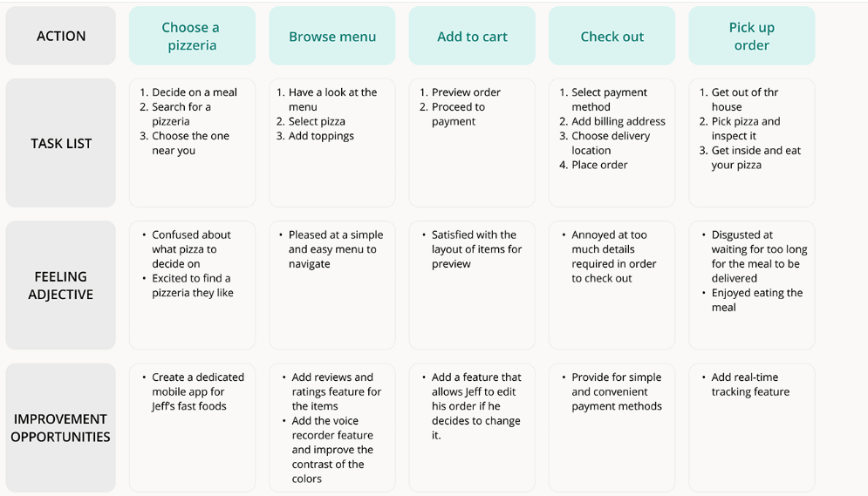

**DESIGN PROCESS: Paper wirefra**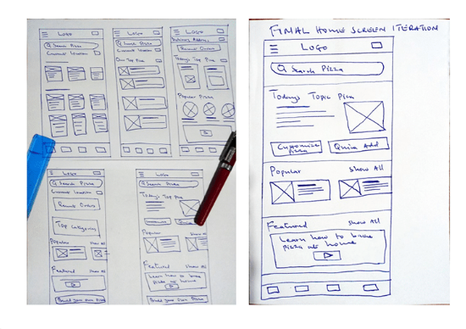

**DIGITAL WIREFRAMES: Sign up and sign-in pages**

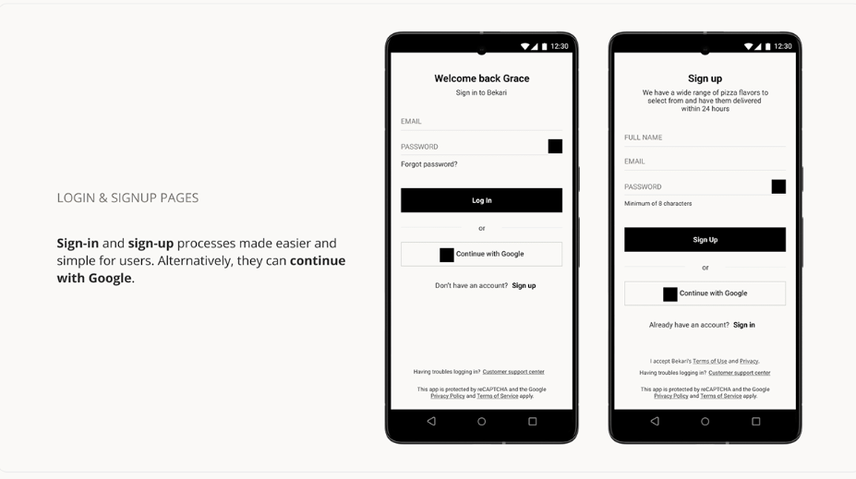

**Usability and study findings:**

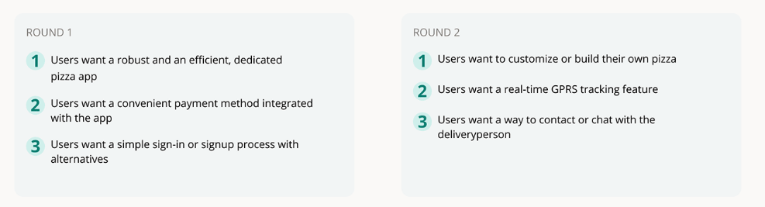

**Refined Designs:**

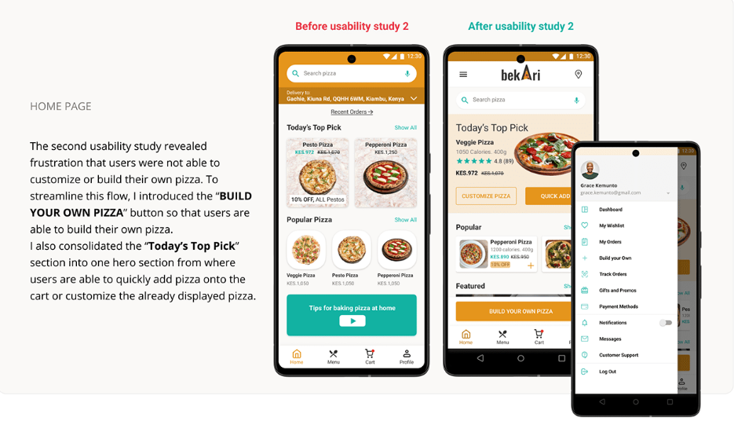

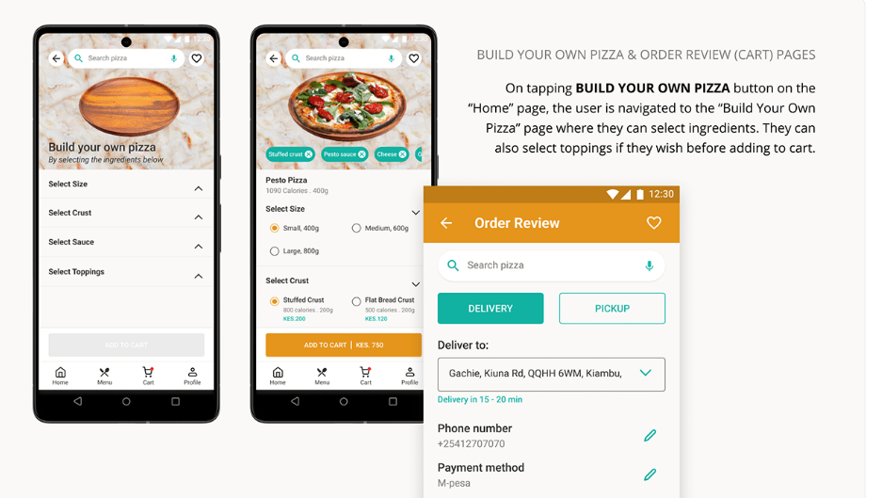

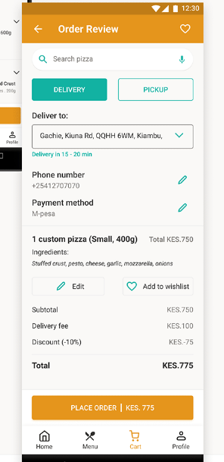

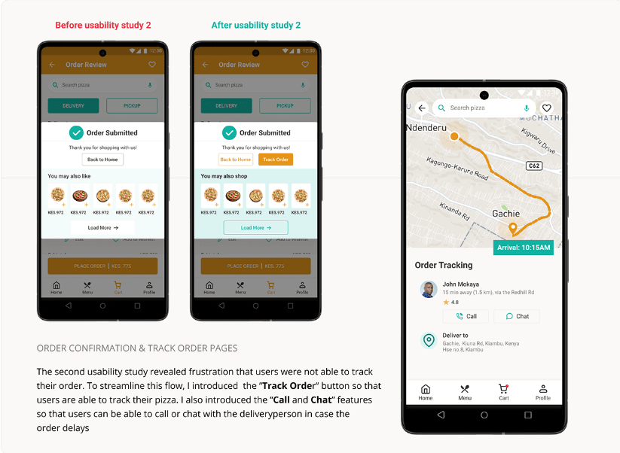

**OTHER SCREENS:**

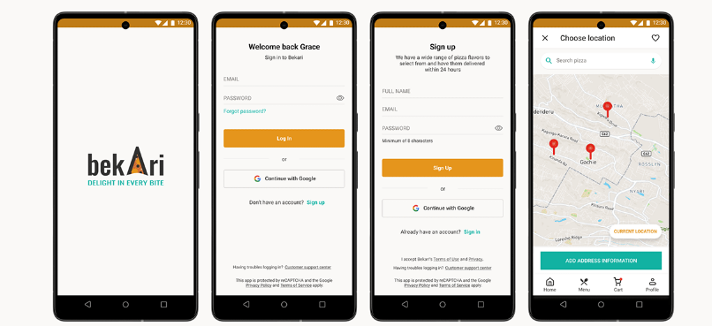

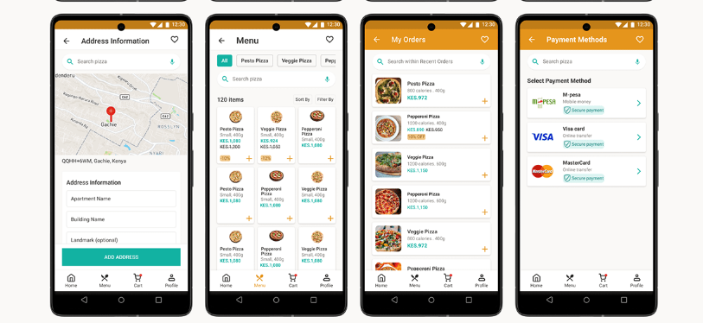

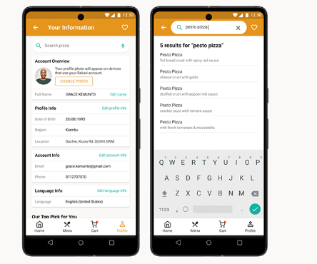

**Next Steps:**

